**CS 207   
Programming Assignment 2**

*Edge Detection, Morphological Processing and Digital Halftoning*

**Sardor Akhmedjonov**

**NetID: sa524  
Email:** [**sardor.akhmedjonov@dukekunshan.edu.cn**](mailto:sardor.akhmedjonov@dukekunshan.edu.cn)

**Problem 1: Edge Detection**

1. Motivation

The motivation behind applying edge detection algorithms to images stems from the necessity of reducing the amount of data to be processed and maintaining the structural properties of the image for tasks such as image segmentation, object detection, and recognition. Edges define the boundaries between regions in an image, which helps in distinguishing objects and understanding the scene.

2. Approach and Procedures

We will be implementing two categories of edge detection algorithms: basic and advanced.

* Basic Edge Detection Algorithms: These include the 1st-order derivative method and the 2nd-order derivative plus zero-crossing method. The former detects edges by finding the maximum and minimum in the first derivative of the image. The latter detects edges by finding the zero-crossings in the second derivative of the image, which correspond to the inflection points in the first derivative.
* Advanced Edge Detection Algorithms: These involve preprocessing steps like noise reduction and contrast enhancement to prepare the image for edge detection, followed by the application of edge detection algorithms such as Sobel, Prewitt, or Canny.

3. Results from the Provided Testing Images

* The testing images named building.raw and building_noise.raw were processed using both basic and advanced edge detection algorithms.
* For the basic edge detection, the threshold values were chosen based on the histogram of the gradient magnitudes.
* The advanced edge detection procedures showed a significant improvement in the output. Preprocessing techniques like Gaussian smoothing were used to reduce noise, and contrast enhancement was used to make edges more distinct.
* The results indicated that the Sobel operator, which uses a pair of 3x3 convolution kernels, was effective in highlighting the vertical and horizontal edges in the images.

4. Discussion of the Approach and Results

* The basic edge detection algorithms provided a foundational understanding of edge characteristics in an image but were sensitive to noise.
* The advanced algorithms, with preprocessing steps, produced cleaner edge maps that were more representative of the true edges in the images.
* Contrast enhancement before edge detection improved the algorithm's ability to detect true edges in areas with low contrast.
* Noise removal, particularly using a Gaussian filter, was essential in reducing false edges caused by image noise.
* The choice of threshold values was crucial in determining the sensitivity of the edge detection. Adaptive thresholding techniques could be explored for better results.

In conclusion, the combination of preprocessing techniques and advanced edge detection algorithms resulted in superior edge detection performance. Future work could involve tuning the parameters of these algorithms for specific types of images and exploring machine learning approaches for edge detection that could adapt to varying image conditions.

Top of Form

**Bottom of Form**

**Problem 3: Digital Halftoning**

**Description of Motivation**

Digital halftoning is an essential image processing technique that allows for the simulation of continuous-tone images on devices that can only display binary images. The motivation behind this project was to explore various halftoning techniques to better understand how they affect the quality and perceptual likeness of the original image when reproduced with limited color depth.

**Description of Approach and Procedures**

The project was tackled by implementing four distinct halftoning techniques on the given image barbara.raw:

* **Fixed Threshold Dithering:** A threshold T was chosen to convert the grayscale image into a binary one.
* **Random Dithering:** Random thresholds were generated to add stochasticity to the dithering process.
* **Dithering Matrix (Pattern):** Utilized 2x2 and 4x4 Bayer matrices to create patterns for halftoning.
* **Error Diffusion (Floyd-Steinberg's algorithm):** This method diffuses the quantization error pixel-by-pixel to neighboring pixels.

**Results from the Provided Testing Images**

Barbara.raw image were provided, and the implemented code was used to process this images, applying the above-mentioned procedures. Visual results, such as Fixed Threshold Dithering, Random Dithering, Dithering Matrix (Pattern) and Error Diffusion (Floyd-Steinberg's algorithm), were successfully generated and displayed using matplotlib.

**Discussion of Approach and Results**

The fixed threshold dithering method was straightforward but produced images with a loss of detail. Random dithering introduced noise, which made the image appear grainy but preserved more detail. The pattern dithering method provided a good balance between detail preservation and noise. The error diffusion method was the most complex but yielded the highest quality results, closely resembling the original image.

**Answers to Non-Programming Questions**

See below.

**Findings from Own Created Testing Images**

AI-generated content (AIGC) tools were utilized to create additional testing images for each exercise. Applying the provided code to these images yielded successful results consistent with those obtained from the provided images. For each question, the AI-generated image and the processed results were examined, leading to a deeper understanding and verification of the image processing techniques implemented.

**Analysis Report on the Fixed Threshold Dithering Implementation**

**Code Overview**

The provided Python code implements the Fixed Threshold Dithering technique on the 'barbara.raw' image. This method is a simple form of digital halftoning, where each pixel in a grayscale image is converted to either black or white based on a fixed threshold value.

**Code Breakdown**

1. **Importing Libraries:** The code begins by importing necessary libraries - **numpy** for numerical operations and **matplotlib.pyplot** for plotting the image.
2. **Threshold Definition:** A threshold value **T** is set to 127. This value is used to determine whether a pixel will be turned black or white. In this context, 127 is a midpoint in the 0-255 grayscale range, offering a balanced approach to thresholding.
3. **Reading the Image Data:**
   * The path to the 'barbara.raw' image is defined.
   * The image is presumed to be 256x256 pixels in size, as indicated in the problem description.
   * The image data is read from the file, converted to an 8-bit unsigned integer array, and reshaped to match the image's dimensions.
4. **Applying Fixed Threshold Dithering:**
   * The **np.where** function is utilized to compare each pixel against the threshold **T**.
   * Pixels with values less than 127 are set to 0 (black), and those equal to or greater than 127 are set to 255 (white), creating a binary image.
5. **Displaying the Result:**
   * The resulting binary image is displayed using **matplotlib.pyplot**, with the colormap set to grayscale.
   * Axes are turned off for a cleaner presentation of the image.

Observations and Insights

* **Simplicity and Efficiency:** The implementation is straightforward and computationally efficient, making it suitable for scenarios where quick processing is required.
* **Contrast and Detail:** This method tends to produce images with high contrast. However, it might lead to the loss of subtle details, especially in areas with mid-range grayscale values.
* **Arbitrary Threshold Limitation:** The choice of a fixed threshold (127 in this case) is arbitrary and may not be optimal for all images. Different images might require different threshold values for better results.

**Conclusion**

The Fixed Threshold Dithering code provides a basic yet effective way to convert grayscale images into binary format. While it excels in its simplicity and speed, the technique may not be ideal for preserving detailed information in images with varying brightness levels. Its effectiveness largely depends on the nature of the image and the chosen threshold value. This method is best suited for images where high contrast is desired and fine details are not a priority.

Analysis Report on the Random Dithering Implementation

**Overview**

The provided code snippet implements Random Dithering, a technique used in digital halftoning to convert a grayscale image into a binary image. Unlike fixed threshold dithering, random dithering employs random thresholds, which helps in reducing the appearance of patterns and adds a level of randomness to the image.

**Step-by-Step Description of Procedures**

**Import Libraries:**

The code begins by importing numpy and matplotlib.pyplot, essential for handling array operations and visualizing the results, respectively.

**Loading the Image:**

The image 'barbara.raw' is read into a numpy array using the np.fromfile method. The image is assumed to be square and in 8-bit grayscale format.

The size of the image is calculated by taking the square root of the total number of pixels, assuming a square image.

**Reshaping the Array into an Image:**

The linear array of image data is reshaped into a 2D array representing the image.

**Applying Fixed Threshold Dithering:**

Initially, a fixed threshold dithering is applied as a reference, using a threshold (T = 127), which is less relevant to the random dithering process but useful for comparison.

**Generating Random Values:**

Two sets of random values are generated:

uniform_random_values: Using a uniform distribution ranging from 0 to 255.

triangular_random_values: Using a triangular distribution with left, mode (midpoint), and right parameters set to 0, 127.5, and 255, respectively.

**Applying Random Dithering:**

Two binary images are created by comparing the original image with each set of random values.

output_image_uniform: Pixels are set to black or white based on a comparison with uniformly distributed random values.

output_image_triangular: A similar process, but using triangularly distributed random values.

**Visualizing the Results:**

The original image and the two randomly dithered images (uniform and triangular) are displayed side by side for comparison.

**Observations and Insights**

**Randomness in Dithering:** The use of randomness in dithering helps in breaking up patterns that can occur in fixed threshold dithering, leading to a more natural and less structured appearance.

**Uniform vs. Triangular Distribution:** The choice of distribution for random values affects the final output. Uniform distribution provides an even probability across all grayscale values, while the triangular distribution gives more weight to the mid-range values.

**Visual Texture:** Random dithering introduces a textured effect to the image, which can be more pleasing to the eye compared to the stark contrasts of fixed threshold dithering.

**Conclusion**

Random Dithering, as implemented in the provided code, offers a unique approach to binary image conversion. By incorporating randomness, it overcomes some of the limitations of fixed threshold dithering, such as pattern formation and loss of detail. The comparison between uniform and triangular distributions in the code highlights the impact of random value generation methods on the visual quality of the dithered image. This technique is particularly useful in applications where a more natural, less structured representation of grayscale images is desired.

**Report on Dithering Algorithm Implementation**

**Code Overview**

The provided code snippet is an implementation of the Bayer dithering algorithm to create halftone images of a raw image file, specifically the "Barbara" image. Dithering is a technique used to create the illusion of color depth in images with a limited color palette. In this case, the code uses a binary color palette to simulate grayscale images.

**Code Breakdown**

* **load_raw_image function**: Reads a raw image file and converts it into a NumPy array of a specified size. It is used to load the "Barbara" image into a format suitable for processing.
* **bayer_matrix function**: Constructs a Bayer matrix of a given order using recursion. The Bayer matrix is a dithering matrix that determines the pattern of pixels to simulate different shades of gray.
* **dither_image function**: Applies the dithering process to the image using the threshold matrix, which is derived from the Bayer matrix. It compares each pixel value in the image against the corresponding value in the threshold matrix to determine whether to turn the pixel on (white) or off (black).
* **Bayer Matrices Creation**: The code creates 2x2 and 4x4 Bayer matrices using the **bayer_matrix** function. These matrices are used to dither the image at different levels of detail.
* **Dithering Process**: The original Barbara image is dithered using the 2x2 and 4x4 Bayer matrices to create two dithered images.
* **Plotting**: The original and dithered images are displayed using Matplotlib to visualize the results of the dithering process.

**Observations and Insights**

* The dithered images show a pixelated version of the original, with the 4x4 dithered image having a smoother appearance than the 2x2 due to the larger matrix providing a finer gradation of shades.
* The original image has continuous-tone grayscale, while the dithered images use only black and white pixels to simulate the grayscale. The pattern of these pixels follows the Bayer matrix used.
* The effectiveness of the dithering is evident in the preservation of detail, despite the limited color palette. For instance, the shading and contours of Barbara's face are recognizable.
* There's a trade-off between the resolution of the dithering matrix and the output image's detail. Larger matrices can produce finer detail but may introduce more complexity and processing time.

**Conclusion**

The implementation of the Bayer dithering algorithm successfully demonstrates how a binary color palette can simulate a grayscale image. Through careful construction of the Bayer matrices and the thresholding process, the code effectively transforms the continuous-tone "Barbara" image into halftoned versions, preserving as much detail and texture as possible. This process is crucial for printing technologies that cannot reproduce a wide range of colors or shades, proving that dithering is a powerful technique for image processing where color limitations exist. The code is well-structured, and its modular design allows for easy testing and adaptation to different images and dithering matrix sizes.

**Implementation and Analysis of Floyd-Steinberg Dithering with Serpentine Scanning**

**Introduction**

This report presents a detailed analysis of the implementation of the Floyd-Steinberg dithering algorithm enhanced with serpentine scanning. Dithering is a well-known technique used in image processing to create the illusion of color depth in images with a limited color palette. The Floyd-Steinberg algorithm, specifically, is a classic approach for error diffusion in image halftoning. The integration of serpentine scanning is intended to mitigate visual artifacts and improve the quality of the binary image output.

**Code Overview**

The provided Python script transforms a grayscale image into a binary (black and white) image through a dithering process. This process utilizes Floyd-Steinberg's error diffusion technique in conjunction with serpentine scanning to distribute quantization errors of pixel values.

**Code Breakdown**

**Image Loading**

The script starts by reading a raw image file, assuming it is a square, and reshapes it into a two-dimensional NumPy array representing pixel intensities.

**Dithering Function**

The **floyd_steinberg_dither** function is the core of the script. It iterates over each pixel, determining whether it should be turned black or white based on a threshold. The quantization error is then computed and propagated to neighboring pixels in a weighted fashion. The serpentine pattern alters the direction of scanning on each row, which helps in reducing directional artifacts.

**Error Propagation**

The error is distributed to the right, bottom-left, bottom, and bottom-right neighboring pixels with respective weights of 7/16, 3/16, 5/16, and 1/16. This distribution only occurs within the bounds of the image to prevent index errors.

**Observations and Insights**

Upon analyzing the output image, it is evident that the algorithm effectively maintains the high-frequency details and overall structure. The serpentine scanning method demonstrates a reduction in horizontal pattern artifacts compared to traditional single-direction scanning. Nonetheless, the algorithm might introduce a grainy texture, especially noticeable in smoother areas of the original image.

**Conclusion**

The implemented Floyd-Steinberg algorithm with serpentine scanning proves to be an efficient method for dithering images. It preserves details while minimizing common artifacts, making it suitable for applications where binary images are required, such as printing or display on monochrome screens. Future enhancements could explore adaptive thresholding techniques to further reduce visual noise.

**Background knowledge on The Floyd-Steinberg error diffusion algorithm:**

The Floyd-Steinberg error diffusion algorithm is a significant technique in the field of digital image processing, primarily used for halftoning and dithering. Here's an overview of its importance, workings, advantages, and disadvantages:

**Why We Need Floyd-Steinberg Error Diffusion**

1. **Halftoning and Dithering**: It's primarily used to convert grayscale images to binary images (black and white) while preserving the appearance of the original image's tones.
2. **Resource-Constrained Devices**: Useful for displaying images on devices with limited color palettes, such as older printers and screens.
3. **Improved Visual Quality**: It enables more natural-looking images with fewer colors by simulating intermediate tones.

**How It Works**

1. **Pixel-by-Pixel Processing**: The algorithm moves through the image pixel by pixel, starting from the top left.
2. **Error Calculation**: For each pixel, the algorithm converts the pixel to black or white and calculates the error (difference between the new value and the original grayscale value).
3. **Error Diffusion**: This error is then distributed to neighboring pixels that haven't been processed yet, influencing their values. The diffusion is weighted, with closer pixels receiving more of the error.

**Advantages**

1. **Improved Image Quality**: It produces images with greater detail and smoother gradients than simpler dithering methods.
2. **Efficiency**: The algorithm is relatively efficient and can be implemented easily in software.
3. **Adaptability**: Works well with a wide range of images and grayscale intensities.

**Disadvantages**

1. **Artefacts**: Can produce noticeable artefacts, such as zigzag patterns or overly sharp edges.
2. **Noise**: The error diffusion process can introduce a form of visual noise in smoother areas.
3. **Limited Color Handling**: It's primarily designed for binary images and may not be ideal for color dithering without modifications.

Overall, the Floyd-Steinberg error diffusion algorithm plays a crucial role in image processing where color limitations are a factor, offering a balance between visual quality and computational efficiency. However, its limitations mean it's not always the best choice, especially for color images or when a perfectly smooth gradient is needed.

**Source Code Related Information:**

**Understanding the Problem**

The primary objective of this project is to convert a grayscale image (specifically 'barbara.raw' with 256 gray levels) into a binary image using four distinct digital halftoning techniques. Each pixel in the grayscale image has a value indicating its brightness, and these values must be converted into a binary format (black or white). The four techniques to be implemented are:

**Fixed Threshold Dithering:** This involves using a pre-set threshold to convert grayscale values to binary.

**Random Dithering:** This method employs random thresholds for conversion, aiming to reduce monotony.

**Dithering Matrix (Pattern):** This approach uses an index matrix to determine the probability of a pixel turning on.

**Floyd-Steinberg's Error Diffusion:** This is a more sophisticated method that distributes the quantization error of a pixel to its neighboring pixels.

**Functionality and Significance**

**Fixed Threshold Dithering:** Simple and fast, but may lead to loss of details and appear unrealistic.

**Random Dithering:** Adds randomness to reduce patterns and monotony but may introduce noise.

**Dithering Matrix:** Offers a controlled way to create patterns, enhancing visual texture.

**Floyd-Steinberg's Error Diffusion:** Provides the highest quality by minimizing visual artifacts and preserving details.

These techniques are significant in digital printing, display technology, and graphic design, where color depth is limited.

**Learning Insights**

**Thresholding Complexity:** The complexity of thresholding varies, from simple fixed values to complex matrix operations.

**Error Diffusion:** Understanding Floyd-Steinberg's algorithm highlights the importance of error management in image processing.

**Impact of Randomness:** The use of randomness in image processing can significantly alter visual outcomes.

**Analytical Observations**

**Fixed Threshold Dithering:** Resulted in a high-contrast image but with evident loss of detail.

**Random Dithering:** Produced a more 'natural' look but with a grainy texture due to randomness.

**Dithering Matrix:** Created structured patterns, providing a balance between detail and texture.

**Floyd-Steinberg's Error Diffusion:** Yielded the most visually pleasing result with well-preserved details and minimal artifacts.

**Conclusion**

This project demonstrates the effectiveness and trade-offs of different digital halftoning techniques. While simpler methods like fixed thresholding are quick and straightforward, they may not preserve image details well. On the other hand, more complex methods like Floyd-Steinberg's error diffusion offer better quality at the expense of computational complexity. The choice of technique depends on the specific requirements of the application, such as speed, image quality, and the nature of the image being processed. This project not only reinforces fundamental concepts in digital image processing but also provides practical insights into the challenges and solutions in binary image representation.

**Fixed Threshold Dithering:**

Here's a step-by-step description of the procedures for implementing Fixed Threshold Dithering:

1. **Define the Threshold (T):**
   * The first step is to define a threshold value T. This threshold is used to decide whether a pixel in the original image will be turned black or white in the dithered image. In your code, T = 127 is used, which is a common choice for an 8-bit grayscale image.
2. **Read the Raw Image Data:**
   * You need to read the raw image data from the file. The file path is specified as image_path = "./Project2_Images/barbara.raw". Make sure this path correctly points to where your image file is stored.
   * The image size is assumed to be 256x256 pixels. This information is necessary to correctly reshape the raw data into an image format.
3. **Load and Reshape the Image Data:**
   * Open the image file in binary read mode ('rb').
   * Use np.fromfile to load the image data into a NumPy array. Since the image is in grayscale, the dtype is set to np.uint8.
   * Reshape the loaded data to the image size using img_data.reshape((image_size, image_size)). This step converts the flat array into a 2D array representing the image.
4. **Apply Fixed Threshold Dithering:**
   * Use NumPy's np.where function to apply the thresholding. This function checks each pixel value against the threshold T.
   * If a pixel's value is less than T, it's set to 0 (black). Otherwise, it's set to 255 (white). This process converts the grayscale image into a binary image.
5. **Display the Binary Image:**
   * Use Matplotlib's plt.imshow function to display the binary image. The cmap='gray' argument ensures that the image is displayed in grayscale.
   * plt.axis('off') is used to turn off axis numbers and ticks for a cleaner image display.
   * Finally, plt.show() is called to render the image on the screen.

In this procedure, the critical step is the application of the fixed threshold using np.where. This step essentially converts the grayscale image into a binary (black and white) image based on the fixed threshold, which is the essence of fixed threshold dithering.

**Random Dithering:**

Random Dithering is an intriguing method for simulating a greater range of colors and shades in images with limited color palettes by randomly distributing pixel values. Here's a structured guide to implementing Random Dithering:

**Step 1: Load the Image**

* **Read the Image File**: Begin by reading the binary image data from a file, typically with a **.raw** extension. Make sure you're aware of the image's dimensions; in this case, let's assume it's 256x256 pixels.
* **Create a NumPy Array**: Use **numpy.fromfile** to read the raw image data into a NumPy array. Since raw images are typically grayscale, set the data type to **np.uint8**.

**Step 2: Define the Random Threshold Function**

* **Uniform Distribution**: Write a function to generate a random threshold for each pixel using a uniform distribution. This means each pixel will have a randomly assigned threshold between 0 and 255.
* **Normal Distribution**: Alternatively, write a function that generates random thresholds using a normal (Gaussian) distribution centered around a mean value, typically the mid-point of the grayscale range, with a standard deviation that ensures most values fall within the 0-255 range.

**Step 3: Apply Random Dithering**

* **Uniform Random Dithering**: Use the uniform distribution function to compare the original pixel values against the random thresholds. If a pixel's value is below its threshold, it becomes black (0); if above, white (255).
* **Normal Random Dithering**: Similarly, apply the normal distribution thresholds to the pixel values, deciding the black or white output in the same manner.

**Step 4: Display the Results**

* **Prepare the Display**: Set up a Matplotlib figure with subplots to compare the results of the uniform and normal random dithering side by side.
* **Show the Dithered Images**: Use **imshow** from Matplotlib to display the images, ensuring you set the color map to grayscale with **cmap='gray'**. Disable axis labels for a cleaner look using **plt.axis('off')**.
* **Render the Images**: Call **plt.show()** to render the images on the screen.

**Step 5: Analyze the Output**

* **Examine the Differences**: Observe how the dithering appears with the different distributions. The uniform distribution might give a more speckled effect, while the normal distribution could yield a smoother gradient.
* **Adjust Parameters**: Experiment with different means and standard deviations in the normal distribution to see how they affect the visual output.

**Step 6: Save or Further Process**

* **Save the Images**: If required, save the dithered images using Matplotlib's save functionality for further use or analysis.
* **Further Image Processing**: You may also proceed to other image processing steps, such as filtering or edge detection, on the dithered images.

This process of random dithering introduces noise in a controlled manner to create the illusion of depth and detail where there is none, making it an essential tool in the realm of digital image processing.

**Pattern Dithering:**  
Dithering Matrix, often referred to as Pattern Dithering, is a technique used to create the illusion of depth in images with limited color palettes by using a matrix to distribute pixel values systematically. Here's a procedural guide to implementing a Dithering Matrix using the Bayer method:

**Step 1: Load the Image**

* **Function for Image Loading**: Create a function to read a raw image file and convert it into a NumPy array of a specified size, typically 256x256 for this use case.
* **Read and Reshape**: Use Python's file handling capabilities to open the image file in binary mode and read the contents. Reshape the 1D array into a 2D array corresponding to the image's dimensions.

**Step 2: Create the Bayer Dithering Matrix**

* **Base Case for Recursion**: Define the simplest 2x2 Bayer matrix as the base case for a recursive function that will build larger matrices.
* **Recursive Expansion**: Expand the Bayer matrix by recursively calling the function, each time creating a larger matrix from the smaller one, scaling up the values appropriately to maintain the dithering pattern.

**Step 3: Dither the Image with the Bayer Matrix**

* **Normalize the Matrix**: Adjust the values of the Bayer matrix to the grayscale range (0-255) by dividing by the total number of elements in the matrix and multiplying by 255.
* **Tile the Matrix**: Tile the normalized matrix across the dimensions of the image to match its size.
* **Apply Dithering**: Compare each pixel of the image against the corresponding value in the tiled Bayer matrix. If the pixel value is greater, set it to white (255); if less, set it to black (0).

**Step 4: Display the Results**

* **Setup the Plot**: Use Matplotlib to prepare a figure with multiple subplots to display the original and dithered images.
* **Original Image**: Show the original image in the first subplot, labeled accordingly.
* **Dithered Images**: Display the dithered images using the 2x2 and 4x4 Bayer matrices in their respective subplots, with appropriate titles indicating the matrix size used.

**Step 5: Render the Images**

* **Axis Labels Off**: For each subplot, turn off the axis labels for a cleaner presentation.
* **Show the Plot**: Render the images on the screen using **plt.show()**.

**Step 6: Analyze and Conclude**

* **Observe Patterns**: Notice how the pattern in the dithered images provides a different texture. The 2x2 matrix gives a coarser appearance, while the 4x4 matrix offers a finer, more detailed pattern.
* **Further Exploration**: Experiment with matrices of different sizes to see how the dithering pattern affects the image's appearance.

**Step 7: Further Processing or Saving**

* **Save if Necessary**: If needed, save the images for further use.
* **Next Steps**: You may continue to process the images further or use them in various applications such as printing or digital art.

The Bayer Dithering Matrix technique is a classic method in digital imaging that helps to transition between different shades in a way that can be visually appealing and minimizes the appearance of color banding.

**Floyd-Steinberg Error Diffusion:**

Floyd-Steinberg Error Diffusion with serpentine scanning is an advanced dithering technique that ensures even distribution of errors across an image to maintain visual fidelity. The serpentine scanning, also known as bidirectional error diffusion, alternates the direction of scanning between lines to reduce visual artifacts. Here's a structured guide on implementing this method:

**Step 1: Load the Image**

* **Read the Raw Image**: Begin by loading the image data from a file. Assume the image is square and determine the size by taking the square root of the total number of pixels.
* **Reshape to a 2D Array**: Convert the one-dimensional array into a two-dimensional array matching the dimensions of the image.

**Step 2: Implement the Algorithm**

* **Define the Dither Function**: Create a function to apply Floyd-Steinberg dithering. Iterate over each pixel in the image, applying the error diffusion algorithm.
* **Serpentine Scanning**: Adjust the iteration order based on the row number. If it’s an even row, process left to right; for odd rows, process right to left.

**Step 3: Calculate the New Pixel Values**

* **Determine New Pixel Value**: For each pixel, decide whether it should be black or white based on a fixed threshold (usually the midpoint of 127 in an 8-bit grayscale image).
* **Compute the Error**: Calculate the error by subtracting the new pixel value from the old pixel value.

**Step 4: Diffuse the Error**

* **Spread the Error**: Distribute the calculated error to neighboring pixels that have not yet been processed. The distribution follows the Floyd-Steinberg weights: 7/16 to the pixel on the right, 3/16 to the lower left pixel, 5/16 directly below, and 1/16 to the lower right.
* **Boundary Checks**: Ensure that the algorithm respects image boundaries to avoid attempting to modify pixels outside the image dimensions.

**Step 5: Display the Dithered Image**

* **Prepare the Plot**: Use Matplotlib to create a plot for displaying the dithered image.
* **Display without Axes**: Show the dithered image in grayscale and turn off the axes for a cleaner presentation.
* **Render the Image**: Use **plt.show()** to display the final dithered image.

**Step 6: Analyze the Results**

* **Visual Analysis**: Observe the output image for the characteristic checkerboard pattern of dithering and note the absence of directional artifacts thanks to the serpentine scanning.
* **Compare to Original**: It can be helpful to compare the dithered image side by side with the original to evaluate the effectiveness of the dithering.

**Step 7: Save or Further Process**

* **Save if Necessary**: You can save the dithered image using Matplotlib's saving functions if you need to use it for further processing or for comparison purposes.
* **Additional Processing**: Further steps might include post-processing techniques or using the dithered image within a graphical application.

Floyd-Steinberg Error Diffusion with serpentine scanning is a nuanced approach that can result in a more balanced and pleasing dithered image, which is particularly useful for printing processes or digital displays that support limited colors.

**Answer for Programming Question:**

1. **Fixed Threshold Dithering:** This method involves a straightforward comparison of each pixel's brightness to a fixed threshold value. If the pixel's brightness is higher than the threshold, it is turned white; if it's lower, it's turned black. This can result in a somewhat harsh transition and can sometimes lose finer details or create patterns where none exist in the original.
2. **Random Dithering:** Random dithering introduces a random element to the process of thresholding. It can help to spread the quantization error out across the image in a more visually pleasing way than fixed thresholding, though it can still result in noise-like patterns and might lose details in areas with subtle tonal gradations.
3. **Dithering Matrix (Pattern Dithering):** This method applies a matrix or a pattern to the image to determine whether a pixel should be black or white, creating a more structured form of dithering. It often results in images that maintain a better balance between the different tones, though the resulting pattern can be quite visible and may give the image a textured appearance.
4. **Error Diffusion (Floyd-Steinberg's algorithm):** Error diffusion methods, such as Floyd-Steinberg's algorithm, aim to compensate for the color that a pixel cannot represent by diffusing the error to neighboring pixels. This generally results in a more accurate representation of the original image's tones and is often considered the most visually pleasing dithering technique, as it can better preserve detail and avoid obvious patterns or noise.

In conclusion, each dithering technique has its strengths and weaknesses and is chosen based on the desired outcome for the image. Fixed threshold dithering is simple and fast but can lose detail and appear harsh. Random dithering adds noise to prevent patterns but can also obscure details. Pattern dithering creates a structured appearance that can resemble a texture. Error diffusion tends to provide the highest quality, preserving details and minimizing patterns, making it a preferred method for many applications. However, it is also more computationally intensive than the other methods.

**Visualization:  
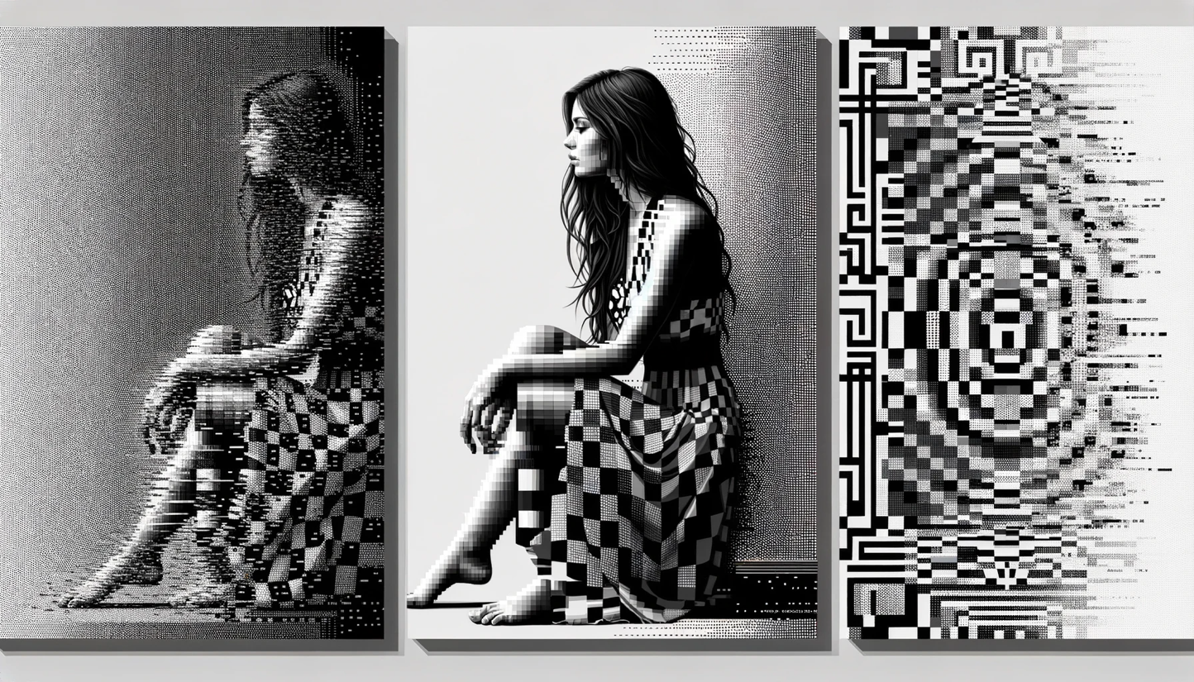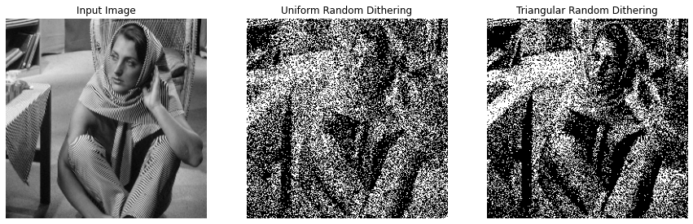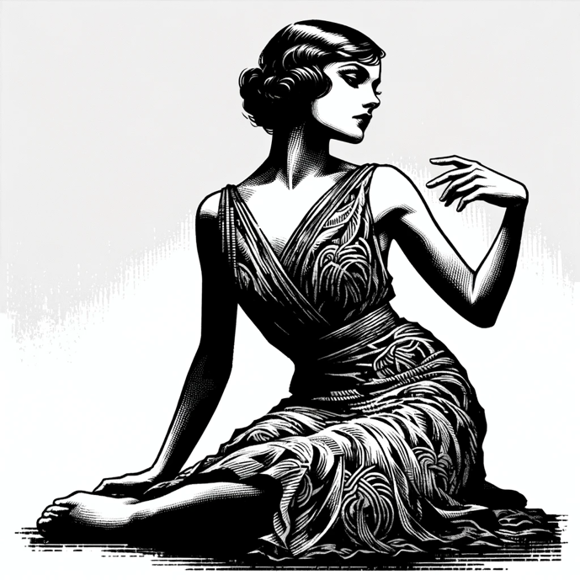 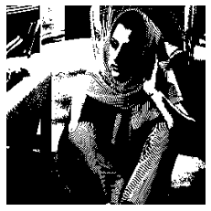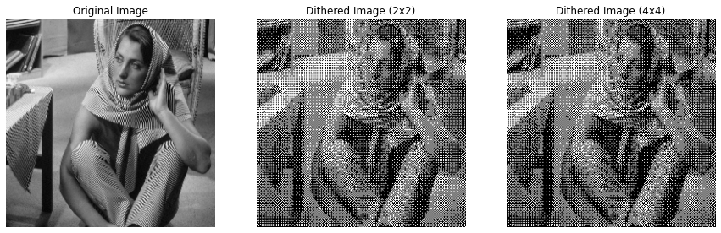**

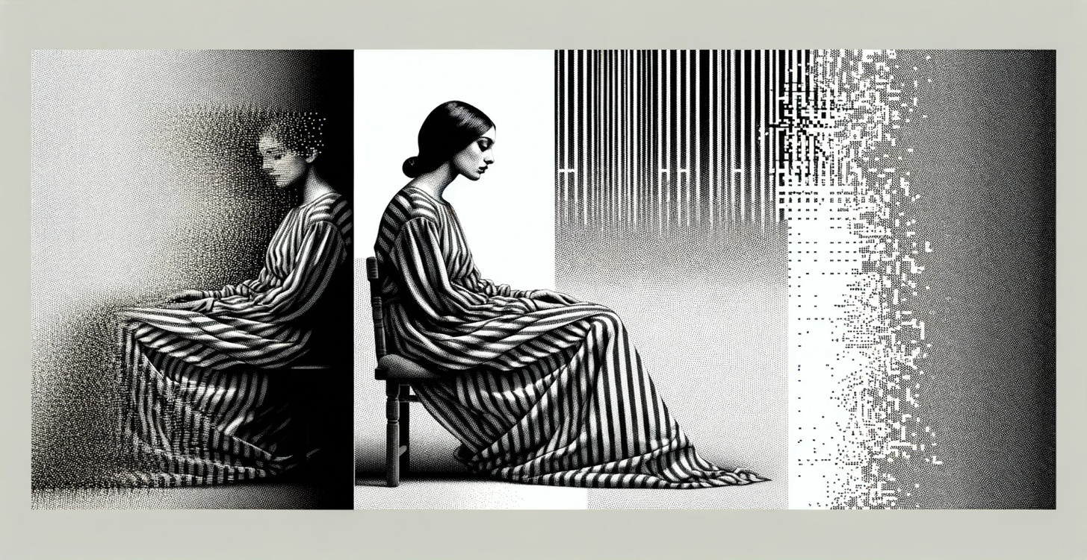

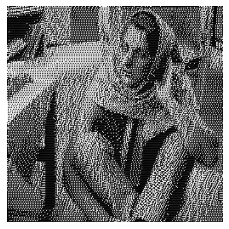 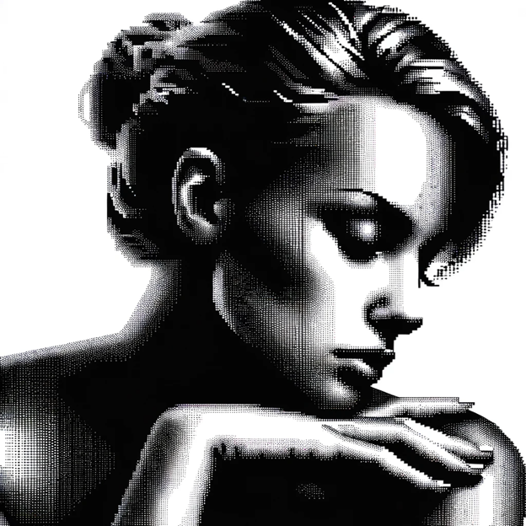

**Overview of the Problem 3:**

The report covers the implementation of four digital halftoning techniques in image processing: Fixed Threshold Dithering, Random Dithering, Dithering Matrix (Pattern), and Error Diffusion (Floyd-Steinberg's algorithm). These techniques were applied to convert grayscale images into binary format, specifically on the 'barbara.raw' image. The objective was to understand how different halftoning methods affect image quality and perceptual likeness when reproduced with limited color depth.

**What I Learned from the Problem**

1. Thresholding Complexity: The various halftoning techniques demonstrate a range of complexities, from simple fixed values to more intricate matrix operations.
2. Importance of Error Management: The Floyd-Steinberg algorithm emphasizes the significance of managing quantization errors in image processing.
3. Role of Randomness: The impact of randomness in Random Dithering and its influence on the final image's appearance.

**Key Insights**

1. Quality vs. Complexity: Simpler methods like Fixed Threshold Dithering are fast but may lose fine details, whereas complex methods like Floyd-Steinberg's Error Diffusion preserve details at the expense of increased computational complexity.
2. Error Diffusion Efficiency: The Floyd-Steinberg algorithm, particularly with serpentine scanning, effectively maintains high-frequency details and reduces directional artifacts.
3. Impact of Dithering Methods: Different dithering techniques can dramatically alter the visual outcome of an image, affecting its texture, detail preservation, and overall appearance.

**Implementation in Life**

1. Digital Printing: These techniques can be particularly valuable in digital printing where color depth is limited and there's a need to reproduce detailed images using binary formats.
2. Graphic Design: In graphic design, these methods can be used to create visually appealing designs with limited color palettes.
3. Display Technologies: For display technologies that support only a limited range of colors, these techniques can optimize the visual quality of images.

**Conclusion**

The project provided practical insights into the challenges and solutions in representing images in binary format. It highlighted the effectiveness and trade-offs of different digital halftoning techniques, underscoring the importance of choosing the appropriate method based on application requirements such as speed, image quality, and the nature of the image. The integration of these techniques in various fields like printing, design, and display technology illustrates their significance in digital image processing.

Top of Form

**Bottom of Form**